XAMPP
# Source: AI Source: Provided by: [Data Path: Persons Table -> ID Column: 1, Name_En Column: Motasem Essam] -> From: [ChatGPT] on [1/16/2026]
XAMPP is a free, cross-platform software stack used to develop and test dynamic web applications locally.

🔤 What does XAMPP stand for?
# Source: AI Source: Provided by: [Data Path: Persons Table -> ID Column: 1, Name_En Column: Motasem Essam] -> From: [ChatGPT] on [1/16/2026]
Letter | Meaning | Description
X | Cross-platform | Works on Windows, Linux, macOS
A | Apache | Web server that handles browser requests
M | MySQL (or MariaDB) | Database server that stores application data
P | PHP | Server-side scripting language
P | Perl (optional) | Another scripting language, less commonly used

🧰 What XAMPP Includes:
# Source: AI Source: Provided by: [Data Path: Persons Table -> ID Column: 1, Name_En Column: Motasem Essam] -> From: [ChatGPT] on [1/16/2026]
- Apache – Web server
- MariaDB – MySQL-compatible database
- PHP – Executes server-side code
- phpMyAdmin – GUI to manage your database
- FileZilla FTP Server (optional)
- Mercury Mail Server (optional)

🧪 What You Can Do with XAMPP:
# Source: AI Source: Provided by: [Data Path: Persons Table -> ID Column: 1, Name_En Column: Motasem Essam] -> From: [ChatGPT] on [1/16/2026]
- Run PHP + MySQL web apps locally
- Develop and test sites without needing a live server
- Use localhost to simulate a web environment
- Manage your database using phpMyAdmin

📦 XAMPP vs WAMP:
# Source: AI Source: Provided by: [Data Path: Persons Table -> ID Column: 1, Name_En Column: Motasem Essam] -> From: [ChatGPT] on [1/16/2026]
Feature | XAMPP | WAMP
Platform | Cross-platform (Win, Mac, Linux) | Windows only
Web Server | Apache | Apache
Database | MariaDB (or MySQL) | MySQL
Languages | PHP, Perl | PHP only
Popular Tool | XAMPP Control Panel | WampServer

📁 XAMPP Default Folder:
# Source: AI Source: Provided by: [Data Path: Persons Table -> ID Column: 1, Name_En Column: Motasem Essam] -> From: [ChatGPT] on [1/16/2026]
After installing, put your PHP files inside the htdocs folder, usually found here:
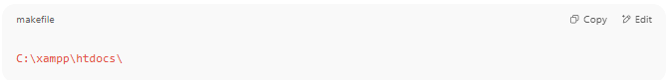
C:\xampp\htdocs\

Access in browser:
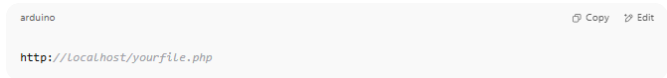
http://localhost/yourfile.php

